Risk Mitigation

Risk ID | Description | Mitigation Action
A | Unavailability of suitable land for waste processing plant | Coordinate well in advance with municipal authorities for leasing or allocation of land
B | Inability to secure consistent municipal waste supply | Sign MoUs with city waste departments for regular waste sourcing
C | Emission levels exceeding environmental regulations | Add emission control technology and conduct regular audits
D | Mechanical failures in turbines or digesters | Perform regular maintenance regimen and keep backup units operational
E | Absence of qualified technicians or engineers | Participate with local technical institutes and provide training
F | Risk of cost overruns or delayed funding | Maintain contingency budget and use multi-source funding
G | Local resistance to waste treatment | Stage awareness campaigns and conduct community participation sessions
H | Government delays in approvals or environmental permits | Start paperwork early and maintain regular contact with regulatory agencies
I | Unanticipated natural catastrophes (e.g., floods that disrupt plant operations) | Design plant with disaster-resistant infrastructure and acquire insurance
J | Sensor data inaccuracies impacting electricity output optimization | Implement IoT-based systems with redundancy and data validation checks

Risk Mitigation Diagram
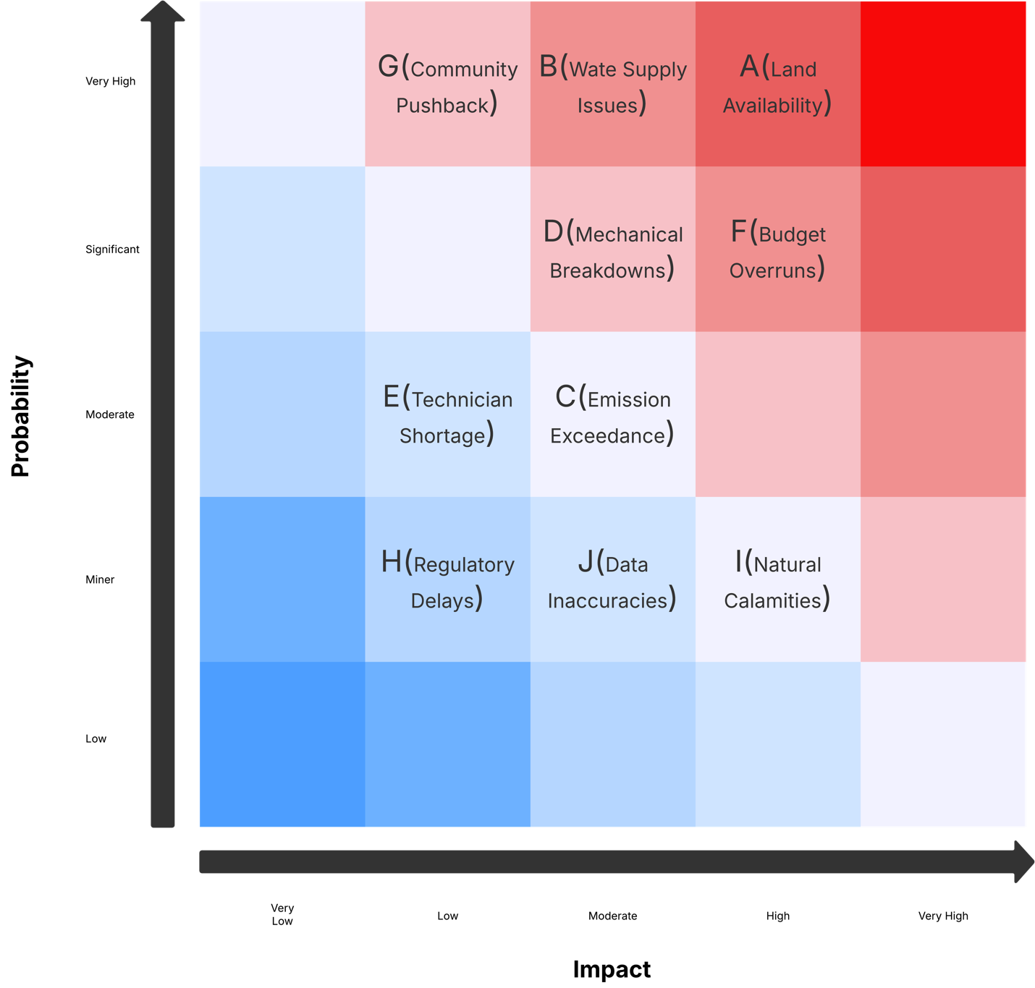

Quality Control Plan

Quality Area | Control Method | Frequency | Responsible Party
Waste Input Quality | Pre-sorting of waste and segregation based on sensors | Daily | Operations Engineer
Emission Monitoring | Real-time automatic emission sensors with automatic alerting | Continuous | Environmental Compliance Officer
Energy Output Efficiency | Match actual output against projected output through analytics | Weekly | Plant Supervisor
Equipment Performance | Monitor turbine/digester efficiency, plan predictive maintenance | Bi-weekly | Maintenance Team
Accuracy of Data Logging | Sensor calibration and system check | Monthly | Data Analyst
Safety Inspections | HSE audits, emergency drills, PPE inspections | Bi-monthly | Safety Officer
Community Feedback | Gather stakeholder opinion on operations | Quarterly | PR and Engagement Officer
Regulatory Compliance | Environmental and safety regulation audits | Quarterly | Compliance Officer

